**Heterogeneity in lobar and near-acini deposition of inhaled aerosol in the mouse lung: preliminary analysis of the LAPD dataset**

Wanjun Gu1, C. Darquenne1*,

1Department of Medicine, University of California, San Diego, USA

**Abstract:**

Laboratory animals are often used to derive health risk from environmental exposure. To do so, it is important to measure not only the total dose of deposited particulates but also their spatial distribution in the lung. A unique database including both high resolution lung anatomy and deposition data in four strains of mice have been recently made available to the research community (Lung anatomy + particle deposition (LAPD) mouse archive: <https://doi.org/10.25820/9arg-9w56>). Using these data, we determined the effect of particle size (0.5, 1 and 2 µm) on the distribution of deposited particles between lobes. Analysis was performed on a total of 34 mice where 3 (16 and 15) animals were exposed to 0.5µm (1µm and 2µm) particles. Lobar deposition (volume) was normalized by the sum of deposition (volume) in each of the five lobes. For each animal, we then calculated the particle deposition to volume ratio for each lobe (). When , particle deposition is proportional to lobar volume; when differs from one, lobar deposition is relatively greater () or smaller () than lobar volume. At the near-acini level, for each animal, frequency distribution is constructed using single-compartment particle depositions. The skewness and standard deviation of the distribution are then calculated and regressed on particle size.

At the lobar level, significant deviation from 1 were found for DV ratio in the cranial lobe (DVcranial), where deposition was relatively greater than lobar volume. DVMiddle, DVCaudal and DVAccessory were all significantly <1 and lower than DVLeft (p<0.01). Furthermore, was positively correlated with particle size (p=0.004) and was negatively correlated with particle size (p=0.026). and also show a negative trend with respect to particle size but the regressions were not significant. At the near-acini level, positive correlations are found between particle size and skewness as well as standard deviation of the distributions.

In conclusion, an uneven distribution of deposited particles of the mouse lung at the lobar level and near-acini level is shown. Thus, depending on the lobe, individual lobe analysis to determine overall deposition may either underestimate or overestimate total lung burden, at least for particles in the micron size range. Varying particle sizes can introduce ineligible deviations of the density and spatial homogeneity of aerosol dosimetry measurements at the near-acini level.

**Material and Method:**

Subjects Preparation:

We use Lung anatomy + particle deposition (LAPD) mouse archive, which is a dataset recently made publicly available. (Glenny et.al) In this dataset, thirty-four awake mice of four different strains: B6C3F1, BALB/C, C57BL/6 and CD-1 were exposed to fluorescent aerosol particles with diameters of 0.5, 1.0 or 2.0 µm. (Table 1) The lungs of these mice were imaged in serial block-face imaging cryomicrotome (Barlow Scientific, Inc, Olympia, WA), acquiring data to isolate aerosol and lung structure. The images were then processed to identify the 3D airway geometry and location of aerosol deposition. The airways from the trachea to the terminal bronchi were identified, labeled and represented as a mesh. The LAPD mouse archive can be accessed and downloaded on <https://doi.org/10.25820/9arg-9w56>.

**(If you want more details, check the paper published by Glenny et. al)**

Data Processing:

**We look at how homogeneous the particles are distributed across the lobe, (lobar level to near acini level)**

In order to compare aerosol particle deposition densities across lobes, lobar volume () is normalized by total lung volume () and lobar particle deposition () is normalized by total particle deposition in the lung (). Then the ratio between normalized lobar particle deposition and lobar volume is denoted as DV ratio. For each mouse sample, DV ratios for five distinctive lobes: left lobe, right cranial lobe, right accessory lobe, right middle lobe and right caudal lobe are denoted as , , , and and calculated based on the formula:

Since is the ratio of normalized particle deposition over normalized lobar volume, it is a good indicator of lobar particle deposition density. If aerosol particle deposition is proportional to the lobar volume, ratio should be one. If aerosol particles are sparsely deposited in a lobe, then should be less than one. If the particles are densely deposited in a lobe, then should be greater than one.

At the near-acini level, spatial distribution of deposited particles is studied. All compartments identified at the near-acini level are sorted and ranked based on the amount of particle deposition received. For each subject mouse, a frequency distribution of single-compartment particle deposition is then constructed. Any compartments with a deposition greater than four are considered as outliers and grouped together at the left tail of the distribution as four. The third moments about the mean (skewness) of the distributions are then calculated by:

Where is the total number of near-acini compartments and is the average near-acini single-compartment particle deposition. On the same note, the standard deviation of the distributions is also calculated.

Statistical Analysis:

Paired five-way ANOVA tests are run to compare the differences of ratios across lobes. ratios are then grouped by strains, sex, particle size and exposure time. Unpaired ANOVA tests are run to compare if ratios are distinctive in different mouse samples of various exposure conditions. ratios of greater variations () are also regressed on particle size.

The third moment and standard deviation are then regressed on particle size. Unpaired T and ANOVA tests are performed to determine if distribution statistics are different across strains and sex.

**Results and discussion:**

**Lobar deposition:**

Average ratios are calculated and tabulated for mouse samples that are exposed to aerosol particles with particle size of one μm and two μm. As shown in table 2, significant deviation from one were found for *DV* ratio in the cranial lobe (*)* where normalized deposition was relatively greater than lobar volume. , and were all significantly smaller than one and lower than (p < 0.01). The DV ratios tend to have greater variations and deviate more from one with two-micron than with one-micron aerosol particles.

Individual ratios for each mouse sample are plotted with respect to different lobes and particle sizes. As figure 1 shows, heterogeneity of particle deposition across lobes exists and exacerbates with respect to increasing particle size. Regardless of particle size and strain, the ratios are always around one, indicating that particle deposition in the left lobe is generally proportional to the lobar volume. Homogeneity of particle deposition in the left lobe can be explained by the shorter path from the trachea to the left lobe. After the airflow enters through the trachea, it only passes one biphication to get to the left lobe, making the aerosol particles subjective to less morphological hinderance and energy lost. Unlike ratios, ratios tend to be greater than one, indicating that particles in the cranial lobe are densely deposited relative to the lobar volume. Over-deposition in the cranial lobe can be explained by the large overall biphication angle. Because for mouse, their cranial lobes locate in the upper half of the right lobes. Such morphological characteristics forces the airflow to make a sharp turn before delivered to and cleared from the cranial lobe, causing more significant energy lost of the aerosol particles. In later correlation studies, a positive correlation is found between and particle size (p = 0.004), indicating that larger particle size tends to worsen aerosol clearance in the cranial lobe. On the contrary, caudal and accessory lobes tend to receive less particle deposition proportional to their volumes. This is likely because caudal and accessory lobes locate at the lower half of the right lobe of the mice, making them less accessible to aerosol particles. Furthermore, a negative correlation is found between and particle size (p = 0.026), suggesting that larger particles have more limited accessibility to the accessory lobe. Therefore, individual lobe analysis to determine total lung particle deposition can either overestimate or underestimate the total lung burden, at least for particles in the micron size range. From figure 1, it is evident that of the four strains of interest, BALB/c comparatively yields the most stable DV ratios across different particle sizes whereas most amount of variations can be observed in C57BL/6. Thus, BALB/c is potentially a better animal model for experiments that require minimized variations in lobar deposition. With that said, despite the difference in amount of variations across strains, no significant correlations are found between DV ratios and strains or sex.

**Near-acini deposition:**

At the near-acini level, three sample distributions exposed to aerosol particles of different sizes (0.5 μm, 1 μm and 2 μm) are shown in figure 2. Samples exposed to smaller aerosol particles tend to have more near-acini compartments with particle deposition closer to the mean, indicating a more homogeneous distribution. On the contrary, samples exposed to larger aerosol particles tend to have more near-acini compartments with denser depositions, indicating that heterogeneity is introduced with respect to increasing particle size. The skewness and standard deviation of near-acini particle distributions of all mice samples are calculated and plotted against particle size. Statistically, a positive skewness indicates that the distribution is right-skewed, and a numerically large skewness shows that more compartments have denser particle deposition compared to average.

Previous studies have shown that the likelihood of forming localized area of deposition is correlated to the skewness of the particle deposition distribution among all near-acini compartments. (Darquenne et.al) As shown in figure 3A, there is a positive non-linear correlation between skewness and particle size. This indicates that as particle sizes increase, the distributions tend to be skewed more towards the right, with more compartments with particle depositions above average. On the same note, as particle size increases, a more scattered distribution is observed, evident in Figure 3B. Therefore, it is shown that the association between increasing particle size and heterogeneity at the lobar level persists at the near-acini level. Even within the micron range, varying particle sizes can introduce ineligible deviations of the density and spatial homogeneity of aerosol dosimetry measurements.

What else is out there that agrees with this analysis.

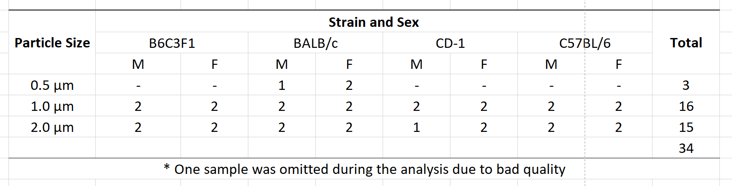

Table 1

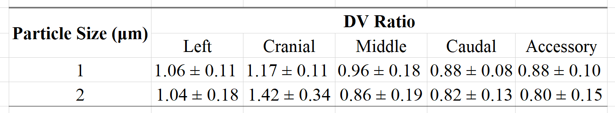

Table 2



Figure 1

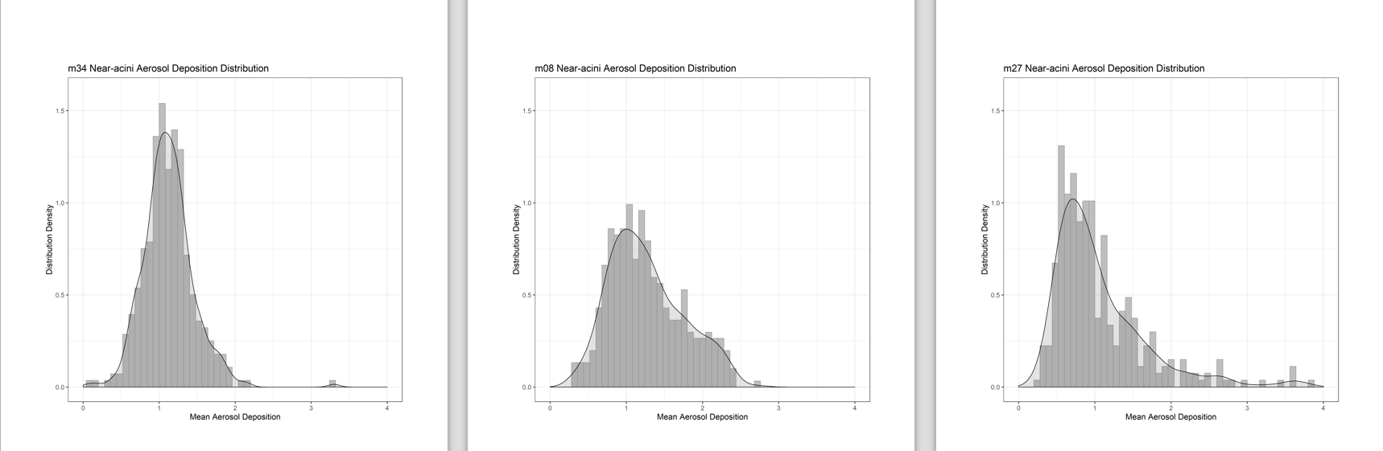

Figure 2

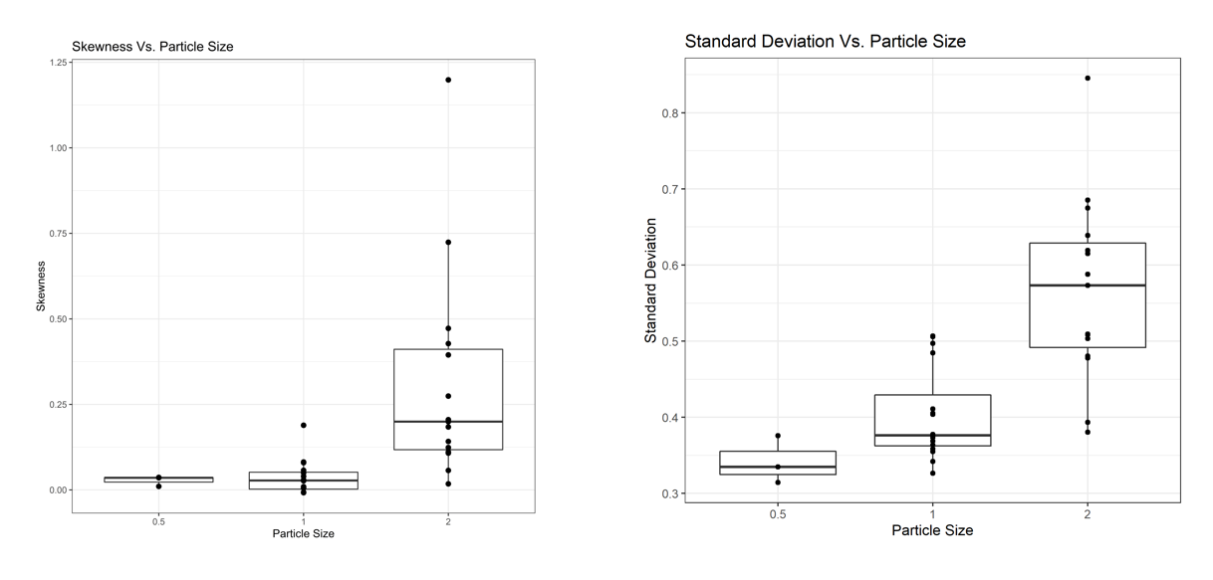

Figure 3 (AB)